**Final Project**

Vaccination has been one of the most successful public health interventions to date, and the U.S. FDA/CDC Vaccine Adverse Event Reporting System (VAERS). The VAERS system is a national early warning system to detect possible safety problems in U.S.

This is to develop a visualization for a U.S based hospital where we are going to represent below

1) Develop a visualization where it shows how many vaccines are given for kids based on age, gender – This is used for hospital management on how vaccines are distributed.

2) Develop a visualization which shows how many vaccines are given based on age and how many cases reported for each vaccine - Health care workers who work with families use this representation.

3) Comparison of events reported based on age and the top 10 risk exposure vaccination reported – Data analysts use this representation to analyze the unknown risk percentage.

4) Develop a visualization that which shows top 10 vaccinations which has more risk percentage and how many vaccines are given based on age- This can be used for lay public.

**Will the overall message change for each audience –** In this project each audience has different research question. If we provide how many vaccines are going to be in demand in future to public, then it doesn’t make any sense to public. Public are not going to use this data. So, we need to be careful on what visualization is designed for who.

As given in the features above, where we are going to display the visualization for what kind of people.

**How familiar will each audience be with issue at hand, with the process for resolution, with the terminology**-

When it comes to feature 1 – Hospital management should be aware of vaccination requirement for coming future. Based on the data and visualization they can easily understand how demand is increasing ad how they should be ready for the future demand.

Feature 2: When health care workers interact with parents then they can show this visualization and explain how many vaccinations should be given as they grow older and when to give vaccines. Using this visualization, the result is going to be simple and easy to explain.

Feature 3 – Public always wanted to know the risk they have when they take vaccines and this representation helps them to know the risk better.

**How will things such as educational levels, age levels, primary language, cultural diversity, and so forth vary among your target audiences:**

We have seen that depends on target audience’s visualization changes. Each visualization will change based on their profession and education levels. For health care workers who work with lay public should know what is their age and their cultural diversity and their language. Depends on that health care workers explain the result in different ways. To build the visualization in this context has no impact of language, culture diversity and education levels. We can see age matters in this visualization. Depend sin age there is a change in vaccine types. So, here age matters.

But in few other cases depends on language, place and diversity values complete visualization picture changes.

**Media / Tools available:**

The best data visualization tools include Google Charts, Tableau, Grafana, Chartist. js, Fusion Charts, Data wrapper, Infogram, Chart Blocks, and D3. js. The best tools offer a variety of visualization styles, are easy to use, and can handle large data sets.

**QlikView:**

The QlikView Desktop is a Windows-based development tool using which developers create QlikView application data model and GUI layout for applications to use at front-end or user end.

**Tableau**

Tableau is a business intelligence tool for visually analyzing data. Users can create and distribute interactive and shareable dashboards, depicting trends, changes and densities of data in graphs and charts. Tableau can connect to files, relational data sources and big data sources to get and process data.

Chart Types: General, interactive, maps, dashboards, and infographics.

Difficulty: Takes a bit of practice.

Cost: Free.

For this project I used Tableau to build the visualizations needed for the specified audiences. I feel Tableau provides best solutions to build creative charts.

Depends on our needs, business requirements and future goals, there are several types of data visualization software’s available based on licensing model. The visualization (or viz) we create depends on:

1. The questions we are trying to ask
2. The properties of our data
3. How we want to present and communicate your insights to others

Here I am planning to use either Tableau or Power BI. While developing the visualization I will be able to decide which tools works better for this requirement. Let’s look at what these tools and how these tools work.

**What is Tableau?**

Tableau is a powerful and fastest growing data visualization tool used in the Business Intelligence Industry. It helps in simplifying raw data into the very easily understandable format.

Data analysis is very fast with Tableau and the visualizations created are in the form of dashboards and worksheets. The data that is created using Tableau can be understood by professional at any level in an organization. It even allows a non-technical user to create a customized dashboard.

I would like to use below plot types to represent these visualizations. Let us see for each audience and what story we would like to convey to them.

**Hospital Management**

Hospital management wants to see to see what vaccines are given for people at which age and their gender. So that they can have a clear picture on how vaccines are getting distributed.

So, I planned to analyze and customize the overall of the data with Tableau Public to create data visualizations. To present the data and graphs, I have chosen bar graph which shows clear pictorial representation

For Hospital management , I will create data visualizations using Tableau, and the story I will tell is that how many vaccines are given for kids based on age, gender so that they can understand which vaccine is in demand and they can have a clear picture on how vaccines are getting distributed for different ages.

**Healthcare Workers**

For healthcare workers, the data visualization should have clear picture on the details of the vaccines so that health workers can help understand the parents on the risk exposure for each vaccine. The Tableau Public allow us to select, choose, and adjust the data to create data visualization as graphs or maps. To present the data and graphs, I have stacked column charts which shows clear pictorial representation

For this, I feel stacked column charts works better. Develop a visualization which shows what is the risk exposure based on age for each vaccine. With this health care workers can explain to the families in a better way with an information of vaccine risk w.r.t age. Same vaccines can be used at different ages with different % of risk.

**The lay Public**

For the lay public, the data visualization should be simple, fancy, and easy to read and understand because the lay public does not have extensive knowledge and background of a particular subject. The data presentation would be a PowerPoint or publication about groups of people and what vaccine they should take, and the visual plots will be created by Tableau Public.

Here I am going to develop a visualization to show which vaccine has high number of reported cases based on risk exposure and reported. The data visualization tool for people in this group is Tableau Public because the program can customize and create a fancy graph. The line graph is a good one to present the lay public because the graph is simple and easy to understand.

Public can look at this visualization and can clearly identify which vaccine they can take, and which has high.

**Hospital Analysts**

Hospital analysts want to search and focus on hidden information, so the data visualization should be focusing on what should be analyzed and what is the impact of hidden data. The data visualization created by Tableau are perfect for this analysis because the program can select, search, and customize the data for specific cases. For I would like to use Column histograms with colors.

The story I will present is that what is risk exposure percentage for unknown gender, and they can analyze further on how these are not ignored and this can be analyzed better by analysts so that they can reduce hidden data further. For the data visualizations, Tableau can add analytical details in the graphs, such as trend and forecast lines, which can add more value in analyzing data.

This visualization will tell us about how many vaccines are given for children based on their age. For more sophisticated information I divided at gender level. Here I used Bar Chart to explain the story in an easy way. Hospital Management has basic technical knowledge on what is happening in their hospital, but they might not have on hand data on what is happening on where. Hospital management means they are educated enough to understand the visualization with basic explanation.

Here I used vaccine type field and calculated count of it and used that count on Y axis. I have given X-axis with Age field and I need to include Gender in this data So Instead of adding more columns on X and Y-axis, I added gender to color so the bar will be divided into number of genders available. There are Male, Female and Unknown gender types available. Below is the graph with result of it.

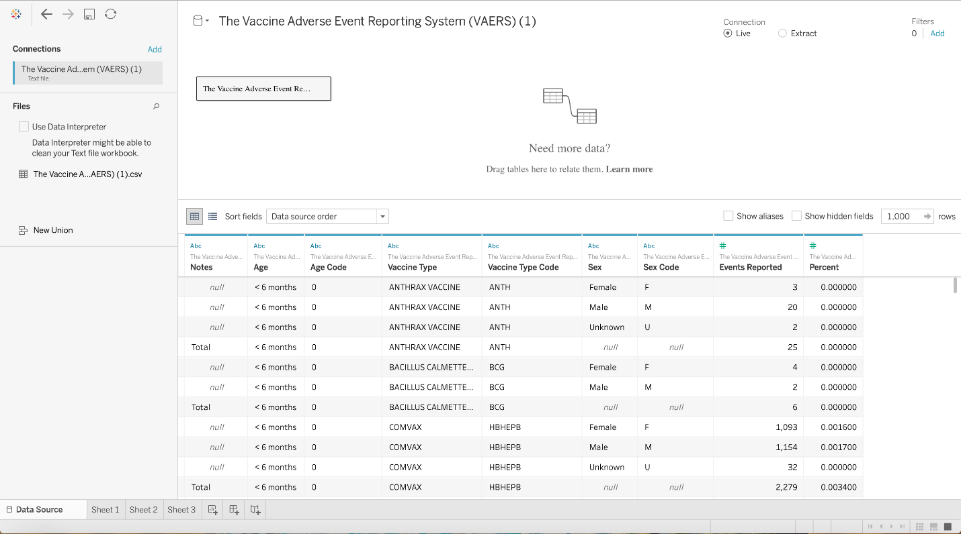

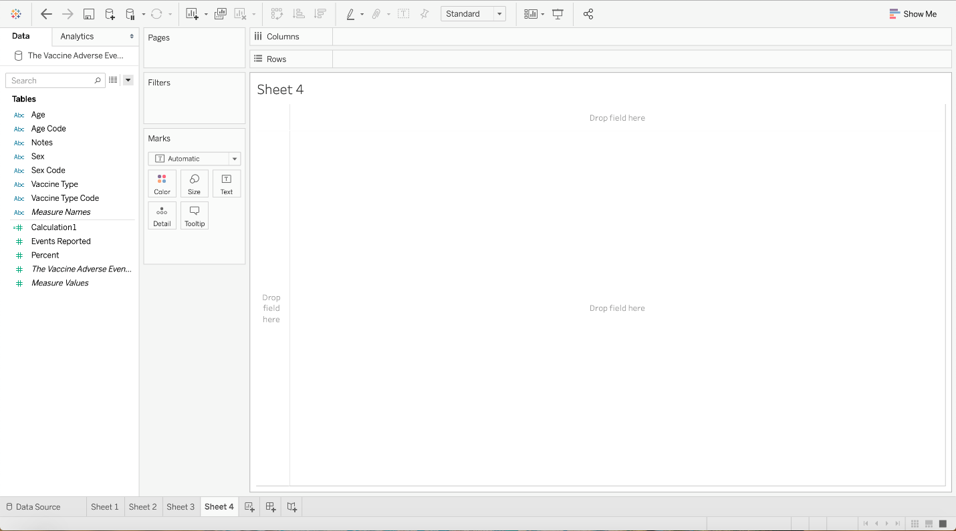

Here, I added visual cues to this graph to represent story in a different way and add more value to the visualization. By adding visual cues, we can draw different story from the graph. Below I added bubble shape to the same story. We can see that gender wise; how many vaccines are given for children based on age.

We can see above, for Male numbers of vaccines given from range 50 to 80 and for female number of vaccines given are from range 60 to 80. For Unknown gender the vaccines given are from range 30 to 50. With this graph we can easily say the range of vaccines, which is not possible with bar graph.

I tried to represent he same using whisker plots. Its full name is Box and whisker plots. It tried to represent the near by items in that line into one box and shows how the count varies by gender. Each dot in below graph represents age.

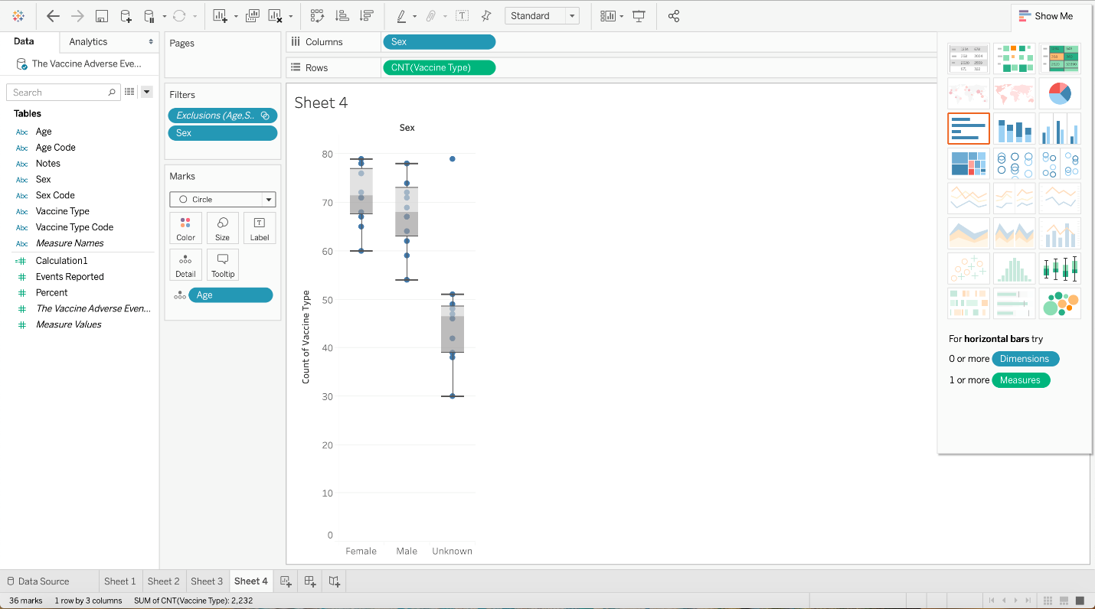

Here I represented the same question using multiple graphs. I feel the Bar graph with color specification for gender shows the correct result with clear understanding for hospital analysts.

**Healthcare Workers**

Usually healthcare workers will spend their day working with children’s family where health care workers explain the parents on how vaccines are working and how many vaccine should be given to children at what age and what are the risks comes with those vaccines.

Health care workers should have more information on what is happening around vaccines and they should be in a position to suggest families which vaccine to take and which one we should avoid.

Here I have taken two graphs and added them into a dashboard to give more information to the families.

One graph will show how many vaccines one should take based on their age. For this I used Vaccines count on Columns (Y-axis) and age on rows (X-axis). I have chosen bar graph and to give clear information when a health worker looks at the data, I have given count as a text on each bar. This gives easy understanding and there is no need to understand the visualizations technically.

Second graph will give information on how many events reported for each vaccination. For this I used number of events on Y-axis and vaccines list on X-axis. I feel line graph will give clear information on which vaccine has a greater number of cases reported. We can clearly say FLU3(seasonal) vaccine has highest reported cases and people should be careful if they are planning to take this vaccine.

Here, I added visual cues to the first graph – number of vaccines needed for age. Here I added circle views graph and added vaccine count to circles and age to text with number to text. So, we can clearly say what is the age and how many vaccines needed. This is useful for the people who cannot understand bar graph.

For the same visualization story, I used highlighted tables as shown below. This shows the number of events reported in an ascending order. So we can clearly say FLU3(Seasonal) vaccine has high number of events reported and followed by VARCEL vaccine.

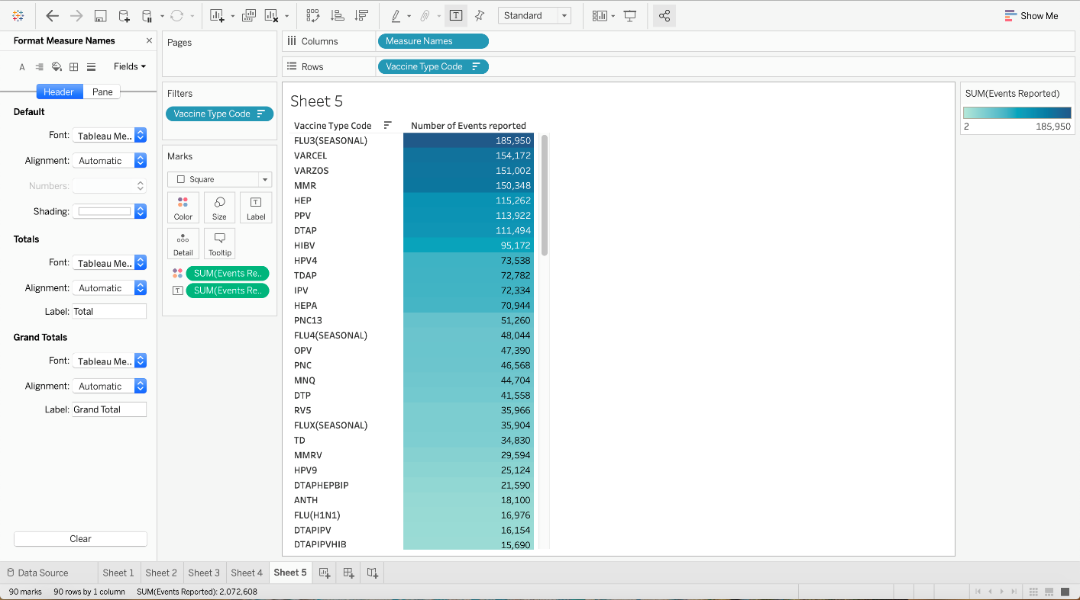

Among all above graphs I feel circles view graph and highlighted table graph shows the needed information with visual cues without missing any data and most importantly not confusing the healthcare workers.

**The lay Public**

We can show the visualization which shows top 10 vaccinations which has highest risk exposure percentage and how many vaccines should be given based on age. Lay public can have different education levels, age, cultural backgrounds with different ethnicity. So, we should be given a detailed written explanation on what to look at the graph and how to understand the visualization.

First visualization gives information on most risk involved vaccinations available. With this public can have an idea while taking this vaccine. There is different between number of events reported and risk exposure percentage. For example, on a vaccine 100 people reported of an issue but the percentage of the risk effect can be very low. So, priority should be risk exposure and then number of events.

Here, I added visual cues to the first graph, i.e. Top 10 vaccinations with highest risk exposure. In previous graph I have taken a table graph and here I have taken highlight table. By default, it adds colors the values. The vaccines with highest risk exposure show dark color and with less exposure shows light color. We can clearly identify that in below graph.

We can represent top 10 vaccines which high risk exposure in many different ways. I am using bar graphs with a filter of top 10 and its percentage of risk on each bar.

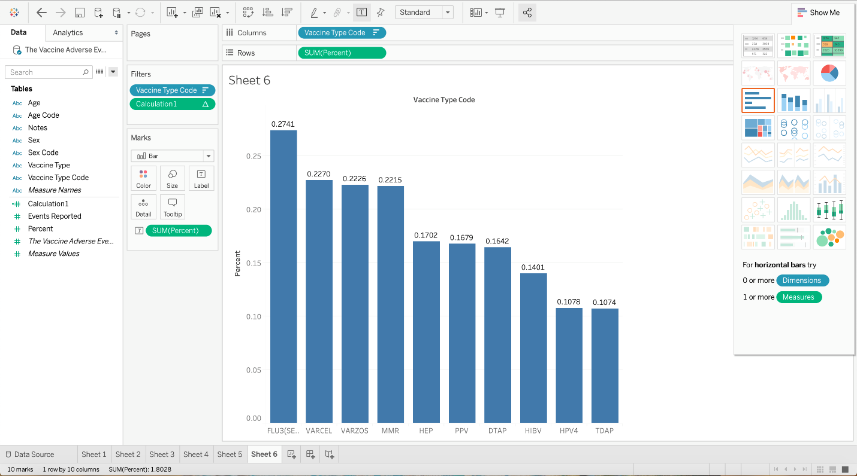

For this story, all three graphs, table graph, bar graph and highlighted tables looks good and giving the same information without deviating from the topic. Here we need to keep audience in mind. We are telling the story to lay public so the best simple and easy to understand graph is table graph with vaccine name and its risk value. This is the best to show for public.

**Hospital Analysts**

Hospital analysts want to search and focus on hidden information, so the data visualization should be focusing on what should be analyzed and what is the impact of hidden data. In this data set data analysts need information on total number of cases reported for each gender so they can focus more on the gender which has a greater number of cases. So, by looking at the graph we can say female children has more cases reported when compared to make and unknown gender.

Secondly, analysts also analyzing on the details on top 10 vaccinations which are in more risk zone. Same type of data can be looked at two different audiences in two different perspectives. This data analysts consider understanding more on why this vaccination is riskier and they will focus on future transactions and research around those vaccines.

For first visualization I have chosen pie diagram to show simply what is the comparison on number of cases reported based on gender. This gives clear picture on which area to focus more and then which vaccination is riskier among all other vaccines irrespective of the age, gender, and other categories.

Second visualization is a table graph which shows top 10 vaccinations which are riskier than other vaccinations which includes color differentiation for each gender.

As this is for hospital analysts, I tried to represent the gender wise events in circle views format. Below graph shows which gender as more evets reported has bigger in size. We can clearly say Female has more number of events reported by vaccines.

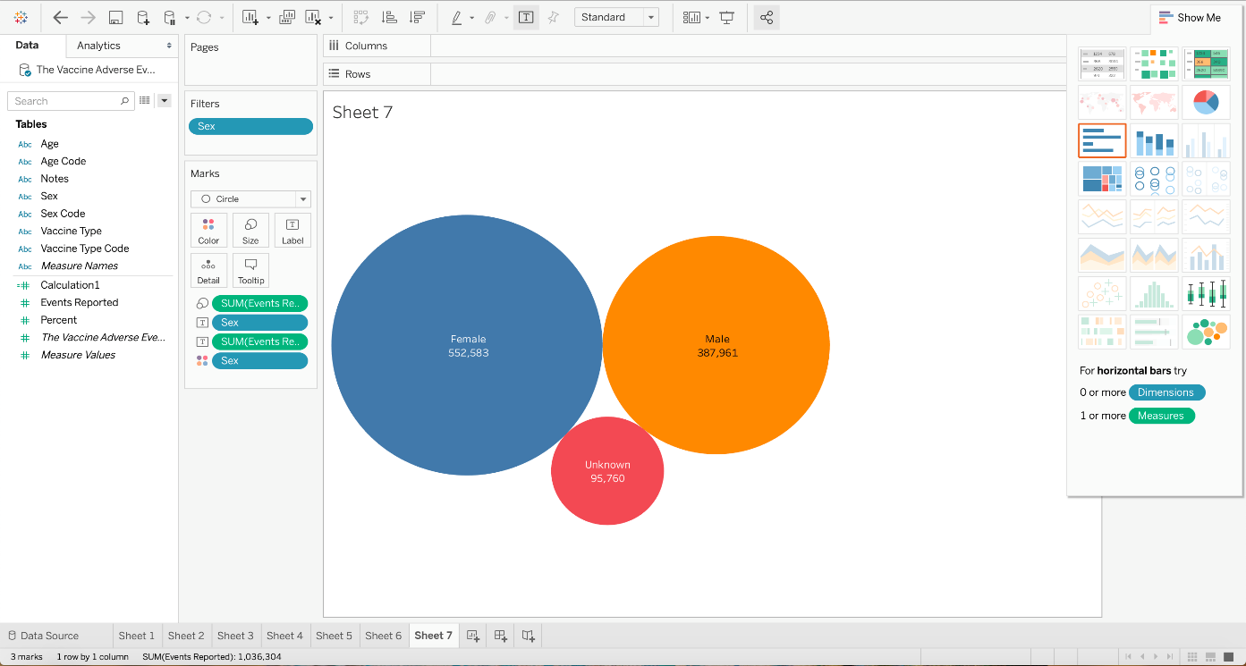

**Feedback mechanisms**

Evaluation is the systematic assessment of the worth or merit of some object. If the data is complex, the ability for us to process the information generated from an evaluation might be limited if we are expecting to connect disparate concepts. At the very least, evaluators might want to consider ways to visualize data simply to improve the efficiency of their communications.

Rather than directive feedback, which ignore the creator’s design strategy, the kind of feedback found in creative workshops help the creator understand how each choice executes that strategy, whether successful or unsuccessful. This kind of feedback not only welcomes more innovative pieces, but also serves as part of the act of creation.

We can do feedback mechanism in different ways.

* **Peer review** is a widely utilized pedagogical feedback mechanism for engaging audiences and data scientists to improve outcomes.
* **OpinionSeer**: It is tool which helps for interactive Visualization of Customer Feedback.
* **Survey**: After completing data visualization lets create a survey with audiences and get to know their level of understanding about the graphs and what they understood. They should be able to understand the story of what we are planning to tell them using the graphs.

Using these feedback mechanisms for every audience I would like to receive feedback and note down their level of understanding and make changes according to that. If we keep feedback mechanism also difficult for audiences then they might not be able to understand what is what. So I would say, I will use Survey or feedback form mechanism for all the audiences so that they can easily give the feedback in simpler and faster way. So that we can improve the visualizations in a better way and can provide the best story to the audience.